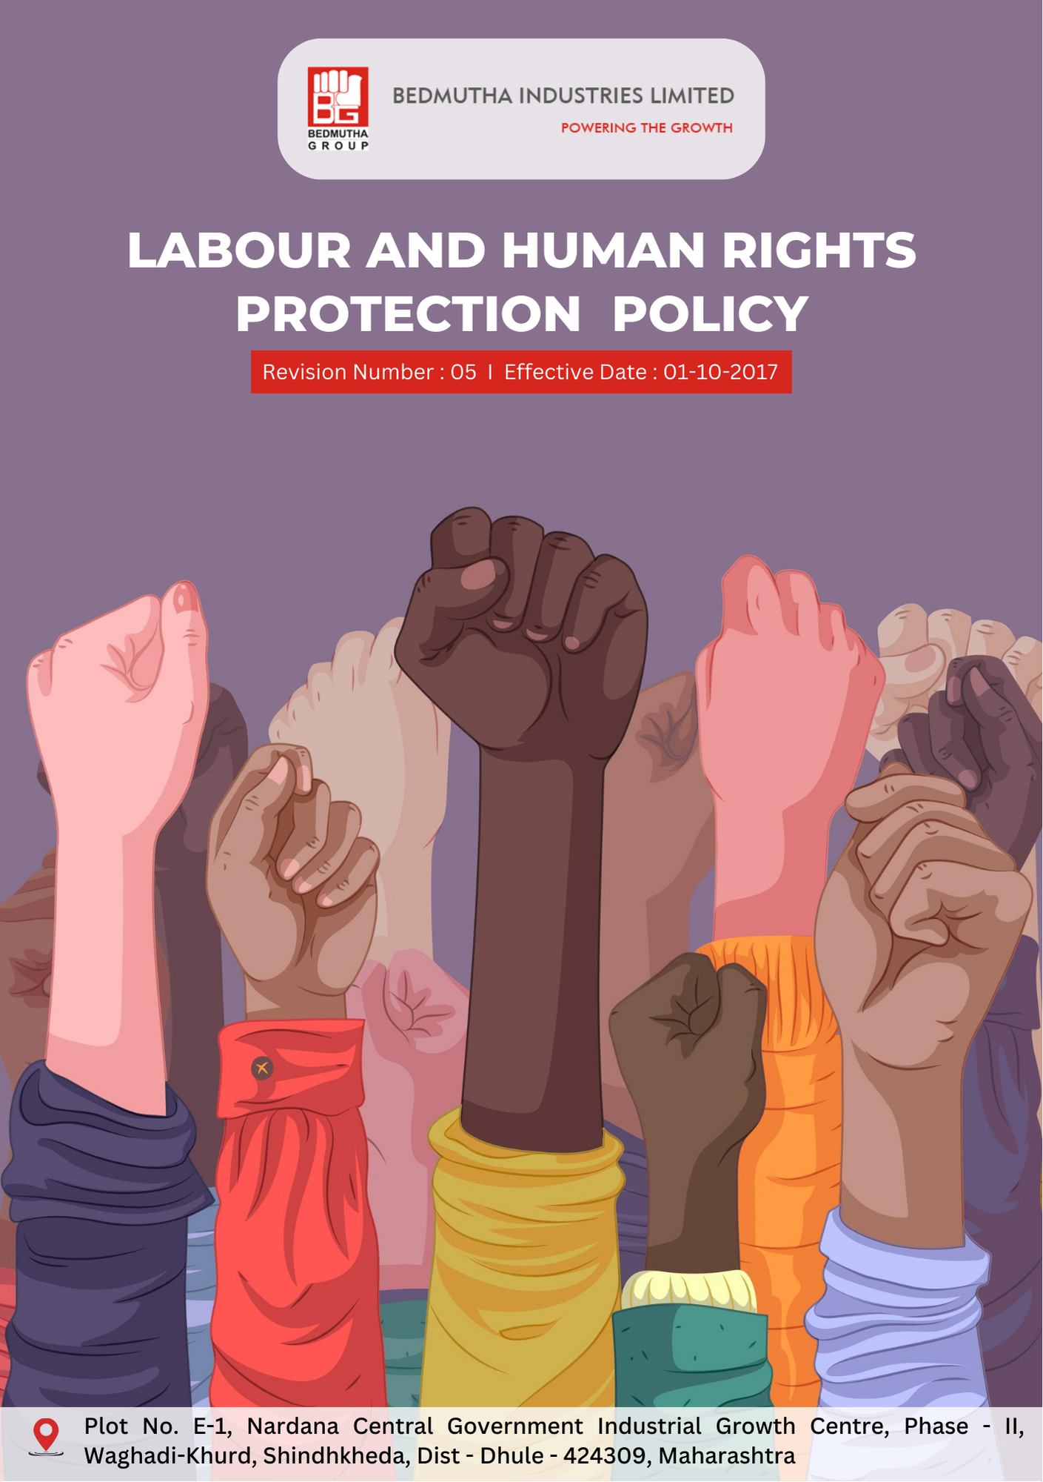

INDEX

1. Labor Rights and Human Dignity Commitment 3
2. Fostering Fair Labor Practices and Human Rights 3
3. Scope 3
4. Responsibilities and Expectations 4
5. Specific Commitments to Labor Rights, Health & Safety : 4
6. Roles and Responsibilities: Governance Introduction 6
7. Internal and External Reporting Mechanisms 7
8. Covered SDGs 8
9. Review Mechanism 8
10. Employee Acknowledgement Form: Labour and Human Rights Protection Policy : 9

Labor Rights and Human Dignity Commitment
Bedmutha Industries Ltd is committed to upholding the dignity, rights, and well-being of every individual involved in its operations. Our policy ensures compliance with international labor standards, promotes fair and inclusive workplace practices, and eliminates child labor, forced labor, and human trafficking from our supply chain. This commitment underpins our responsibility to employees, stakeholders, and society at large.

Fostering Fair Labor Practices and Human Rights
Bedmutha Industries Ltd is dedicated to creating a workplace that respects and upholds labor and human rights across all operations and supply chains. This involves eradicating child and forced labor, promoting fair and ethical labor practices, and ensuring inclusive, safe, and equitable working conditions. Through proactive audits, supplier training, and employee development programs, we aim to uphold international labor standards and enhance our social responsibility.

Our efforts extend to fostering employee well-being through fair compensation, health and safety initiatives, and grievance mechanisms. We work with suppliers, partners, and communities to eliminate human trafficking risks and create opportunities for sustainable livelihoods. These commitments align with Bedmutha's core values of integrity, respect, and sustainable growth.

Scope
This policy applies to all employees, contractual workers, suppliers, partners, and stakeholders associated with Bedmutha Industries Ltd, including all operational facilities, supply chain entities, and service providers. The policy extends to every jurisdiction where Bedmutha conducts business:

Bedmutha Industries Ltd
Address: Plot No. E-1, Nardana Central Government Industrial Growth Centre, Phase - II, Waghadi-Khurd, Shindhkheda, Dist - Dhule - 424309, Maharashtra.
http://www.bedmutha.com/

Responsibilities and Expectations
- Labor and Human Rights Compliance
Bedmutha Industries Ltd adheres to all relevant labor laws and human rights standards, fostering a respectful and equitable workplace while promoting ethical practices across our supply chain. We drive compliance and continuous improvement through:
- Conducting regular labor rights audits to identify and mitigate risks of child labor, forced labor, and other violations.
- Implementing robust supplier screening processes to ensure alignment with human rights principles.
- Establishing grievance mechanisms that enable employees and stakeholders to report concerns confidentially and without fear of retaliation.
- Providing comprehensive training programs on labor rights, workplace ethics, and anti-trafficking measures for employees and suppliers.
- Enforcing non-discrimination practices across recruitment, promotions, and compensation.
- Ensuring safe and healthy working conditions by maintaining compliance with occupational health and safety standards.
- Collaborating with community organizations to promote education and provide alternative livelihoods for vulnerable populations.
- Strengthening supplier engagement to encourage adherence to fair wages and humane working hours.
- Monitoring and regularly reporting on progress toward achieving labor and human rights targets to ensure accountability.

Specific Commitments to Labor Rights, Health & Safety :
- Establishes 2022 as the baseline year for measuring progress and achievements in our labor practices and human rights initiatives.

- Employee Health and Safety:
- Bedmutha prioritizes employee health and safety by implementing comprehensive workplace safety programs, conducting regular risk assessments, and adhering to international safety standards. By 2026, the company aims to achieve a 20% reduction in workplace accidents.
- Bedmutha plans to enhance safety protocols through advanced monitoring systems and quarterly safety drills. By 2026, 100% of employees are expected to receive regular training on health and safety practices.

- Working Conditions
- The company ensures fair wages and benefits that meet industry benchmarks while maintaining transparency in compensation practices. By 2026, Bedmutha aims for 100% of employees to express satisfaction with working conditions, including pay and benefits.
- Bedmutha is focused on fostering two-way communication by introducing feedback mechanisms like surveys and focus groups. By 2026, 90% of employees are expected to feel empowered to report workplace concerns confidentially.

- Labor Relations
- Bedmutha strengthens structured relations with trade unions and employee representatives through joint problem-solving initiatives. By 2026, the company plans to ensure 100% of employees operate under environments with formalized labor relations frameworks.
- Regular meetings with trade unions are set to address workplace concerns, targeting zero unresolved labor disputes by 2026.

- Career Management
- Bedmutha is committed to enhancing employee career growth by offering training programs, skill-building workshops, and career advancement opportunities. By 2026, 85% of employees are expected to participate in at least one professional development initiative annually.
- The company plans to launch a formal mentorship program, aiming for a 25% increase in internal promotions by 2026.

- Child, Forced Labor, and Human Trafficking
- Bedmutha enforces a zero-tolerance approach toward child labor, forced labor, and human trafficking by auditing its supply chain to ensure compliance with international standards. By 2026, 100% of suppliers are expected to pass audits focused on child and forced labor, as well as human trafficking prevention.
- The company collaborates with industry organizations to raise awareness about child labor, forced labor, and human trafficking, targeting 100% employee engagement and outreach to 75% of suppliers by 2026.

- Diversity, Equity & Inclusion
- Bedmutha promotes diversity and equity by recruiting from underrepresented groups and ensuring equal opportunities for all employees. By 2026, the company aims for 30% of leadership roles to be held by women or members of underrepresented groups.
- Training programs are planned to foster understanding of diversity issues, with 100% of employees completing these programs by 2026.

- External Stakeholder Human Rights
- The company engages with external stakeholders, such as suppliers and human rights organizations, to uphold fair treatment and human rights standards across the supply chain. By 2026, 100% of strategic suppliers are expected to adopt human rights practices aligned with international norms.
- Bedmutha is focused on conducting regular human rights impact assessments, targeting a 95% success rate for supplier compliance by 2026.

- Mental Health and Well-being
- The company is committed to improving employee mental health through counseling services, wellness programs, and flexible working arrangements. By 2026, Bedmutha aims to achieve 90% employee participation in mental health initiatives.
- Bedmutha plans to enhance work-life balance, targeting a 15% increase in employee satisfaction with these efforts by 2026.

Roles and Responsibilities: Governance Introduction
The governance structure at Bedmutha Industries Ltd for the Labour and Human Rights Protection Policy ensures the clear allocation of roles and responsibilities to promote accountability, support effective implementation, and sustain continuous progress toward fostering a workplace that respects and upholds labor and human rights. This structure integrates fairness, inclusion, and ethical practices into every operational level, aligning with Bedmutha's commitment to equitable growth and human dignity:

- The Board of Directors oversees the strategic implementation of the Labour and Human Rights Protection Policy, ensuring alignment with the company’s core values and global labor standards. They are responsible for approving targets related to workplace equity, employee well-being, and compliance with international labor regulations. Additionally, they review progress on initiatives such as diversity programs, career development strategies, and external stakeholder engagement.

- The Chief Human Resources Officer (CHRO) leads the execution of the Labour and Human Rights Protection Policy, reporting directly to the CEO and providing regular updates to the Board. The CHRO ensures integration of fair labor practices across all operations, develops frameworks for career progression, and implements initiatives to foster diversity, equity, and inclusion in the workforce.

- Department Heads and Managers implement the policy at the operational level, ensuring compliance with labor laws, health and safety standards, and workplace ethics within their teams. They are tasked with conducting performance reviews, addressing employee grievances, and facilitating two-way communication to improve working conditions.

- The Health, Safety, and Environment (HSE) Team monitors and mitigates workplace risks to ensure the health and safety of employees. They implement regular safety drills, assess risk factors, and provide training on emergency response and workplace safety protocols.

- The Compliance and Audit Team conducts regular audits to ensure adherence to the policy, focusing on labor rights, working conditions, and child or forced labor prevention across operations and the supply chain. They identify gaps, propose corrective measures, and report findings to senior management.

- The Diversity and Inclusion Committee champions initiatives to create an equitable workplace by addressing systemic barriers, promoting recruitment from underrepresented groups, and fostering a culture of belonging. They also ensure the delivery of training programs on unconscious bias and cultural competency.

- Suppliers and Contractors are required to align their practices with Bedmutha Industries Ltd's labor and human rights standards. This includes avoiding child or forced labor, ensuring fair wages, and providing safe working conditions within their operations.

- All Employees are expected to uphold the principles outlined in the policy, including respecting colleagues’ rights, maintaining a safe workplace, and reporting any concerns regarding violations of labor or human rights standards.

- The External Stakeholder Engagement Team liaises with trade unions, labor organizations, and NGOs to promote collaborative efforts for better labor relations and human rights advocacy, ensuring alignment of stakeholder interests with company practices.

Internal and External Reporting Mechanisms
- Internal Reporting mechanisms include quarterly reports from the Chief Human Resources Officer (CHRO) to senior management and the Board, detailing progress on labor rights initiatives, diversity and inclusion efforts, and workplace safety performance. An incident reporting system is available for employees to confidentially report grievances, unsafe working conditions, or violations of labor practices, which are then addressed by the Compliance and Audit Team. These reports also highlight developments in employee training, fair wages, and engagement activities with trade unions.

- External Reporting adheres to internationally recognized frameworks such as the UN Guiding Principles Reporting Framework and the Global Reporting Initiative (GRI). The company publishes an annual Labor and Human Rights Impact Report, detailing progress in areas such as child and forced labor prevention, equitable recruitment practices, and external stakeholder engagement. This report is shared with stakeholders, including suppliers, NGOs, and regulatory bodies, to ensure transparency and foster collaborative improvement.

Covered SDGs
 |  |  |  |  |  | 

Review Mechanism
- The company conducts an annual review of the Labour and Human Rights Protection Policy to evaluate its effectiveness in achieving set goals related to employee health and safety, career management, and compliance with global labor standards. Internal audits, employee surveys, and stakeholder feedback are analyzed to identify gaps and areas for improvement.
- The CHRO leads the review process in collaboration with the Compliance and Audit Team, reviews this policy annually to ensure aligned with evolving regulations, industry best practices, and stakeholder expectations. Any revisions to the policy are approved by the Board and communicated to all employees and partners. Training sessions are held as part of this process to ensure clarity and adherence to updated practices.

(Signature)
Approved By:
Last Review Date: 01-01-2025 Next Review Date: 01-01-2026

Employee Acknowledgement Form: Labour and Human Rights Protection Policy :

I, acknowledge that I have received, read, and understood the Labour and Human Rights Protection Policy of Bedmutha Industries Ltd. I am aware of the company’s commitment to fostering a safe, inclusive, and equitable workplace while upholding the highest standards of labor rights, employee well-being, and ethical practices.
I understand my role in supporting this policy, which includes adhering to fair labor practices, respecting diversity and inclusion, promoting safe working conditions, and actively participating in initiatives aimed at career development and employee engagement.
I agree to comply with all relevant labor laws, report any violations of labor or human rights policies, and contribute to maintaining a respectful and collaborative workplace environment. I also commit to upholding the company’s values regarding the prevention of child and forced labor, promoting open communication, and fostering equity at all levels.
By signing below, I confirm my commitment to supporting Bedmutha Industries Ltd's Labour and Human Rights Protection Policy and contributing to its goals of ethical and responsible business operations.

Employee Name: ______________________
Date: _______________
Employee Signature: ____________________

